**Luxury Housing Sales Analysis – Final Documentation**

**1. Data Pipeline Steps**

**Step 1: Data Collection**

* Gathered raw dataset containing **Luxury Housing Sales** details:
  + Property_ID, Micro_Market, Project_Name, Developer_Name, Ticket_Price_Cr, Unit_Size_Sqft, Configuration, Buyer_Type, Transaction_Type, Purchase_Quarter, Booked_Flag, etc.

**Step 2: Data Cleaning & Preparation**

* **Handled missing values** (imputation / removal).
* **Removed duplicate rows/columns** using Python.
* Converted Ticket_Price_Cr into **numeric type**.
* Derived new features:
  + Price_per_Sqft = Ticket_Price_Cr * 1e7 / Unit_Size_Sqft
  + Year and Quarter_Number extracted from Purchase_Quarter.
  + Booked_Flag (1 = Booked, 0 = Not Booked).

**Step 3: Database Setup**

* Loaded cleaned data into **PostgreSQL**.
* Created schema with 22 columns.

**Step 4: Querying & Analysis**

* Wrote SQL queries to answer **business questions**:
  + Revenue by Developer
  + Average Price Trends by Quarter

**Step 5: Visualization**

* Connected PostgreSQL to **Power BI**.
* Built dashboards with:
  + Line charts for Quarterly Trends.
  + Table showing for Developer/Market comparisons.
  + Stacked columns for Booking Conversion and Sales Channel Efficiency
  + Scatter Plot for Amenity Score vs Booking Conversion Rate
  + Pie Chart for Configuration Demand
  + Matrix Table for Quarterly Builder Contribution

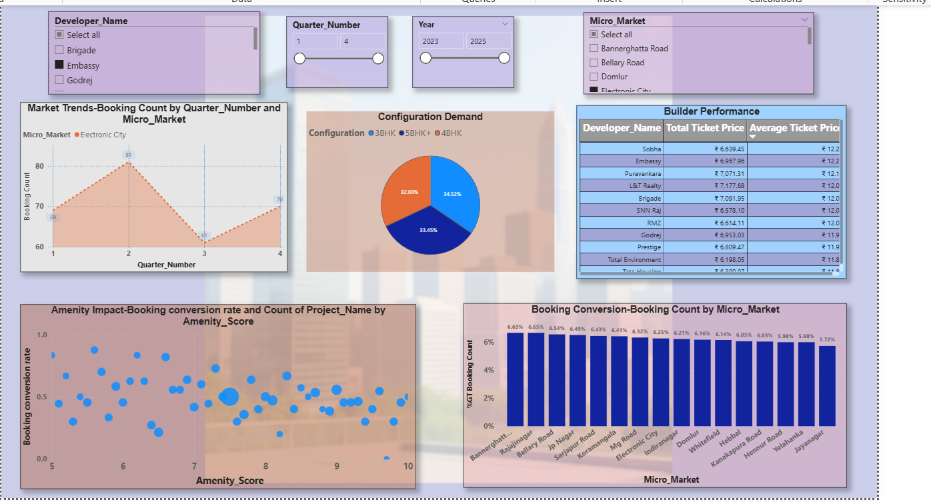

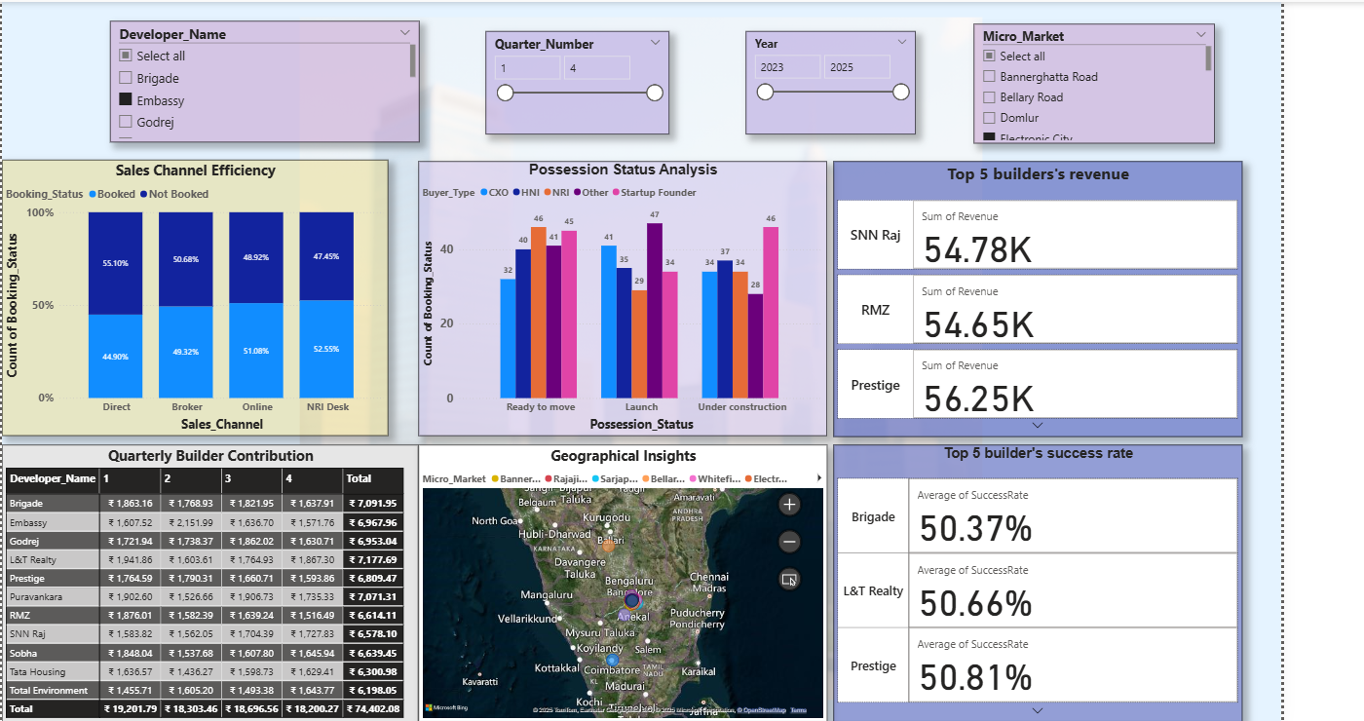

**DAX Measure:**

1.Average Ticket Price = AVERAGE('public house_data'[Ticket_Price_Cr])

2. Booking conversion rate = DIVIDE(SUM('public house_data'[Booked_Flag]),COUNTROWS('public house_data'))

3. Booking Count = SUM('public house_data'[Booked_Flag])

4. Total Ticket Price = SUM('public house_data'[Ticket_Price_Cr])

5. Total_Projects = DISTINCTCOUNT ('public house_data'[Property_ID] )

**2. Business Insights**

📌 **Key Findings:**

* **Top Developers by Revenue**: RMZ, Puravankara, Tata Housing led revenue generation.
* **Micro Market Trends**: Sarjapur Road & Indiranagar showed highest booking conversion rates.
* **Quarterly Trends**: Sales were **seasonal**, peaking in **Q1 and Q4**.
* **Buyer Demographics**: NRI buyers were more likely to purchase in premium localities with higher infra scores.
* **Sales Channels**: Broker-led sales performed best in under-construction projects, while Online channels gained traction for ready-to-move properties.

📊 **Strategic Insight:** Developers should focus more on **premium micro-markets + NRI buyers** and strengthen **digital sales channels**.